GOVERNMENT OF INDIA
Ministry of Commerce & Industry | NICDC
Industrial Corridor Project Management System (IC-PMS)

MODULE 1
Project Definition &
Work Breakdown Structure
Detailed Design Document

Document Version: 1.0 | March 2026 | Classification: Restricted
Prepared by: IC-PMS Solution Architect Team

1. Module Overview

1.1 Purpose & Objectives
Module 1 — Project Definition & Work Breakdown Structure — is the foundational layer of IC-PMS. Every cost record, schedule activity, satellite polygon, document, risk, and contract in the system is anchored to a WBS element created and managed here. Without a properly structured WBS, none of the downstream modules (Scheduling, Cost, Contract, Satellite, Risk, Reporting) can function.
The module is designed to mirror the configuration capabilities of Oracle Primavera Unifier's Project Setup and WBS configuration screens, while being extended with India-specific requirements: NIC coding conventions, PFMS funding milestone alignment, GIS polygon geo-tagging from ISRO/commercial satellite shapefiles, and multilevel OBS integration reflecting the SPV-NICDC-Ministry governance structure.

1.2 Module Scope
Scope Element | Included | Notes
Project Registration | Yes | Full corridor, node, and sub-project setup
WBS Hierarchy (up to 8 levels) | Yes | Configurable per asset class
Milestone & Phase Management | Yes | Dependency-linked, escalation-enabled
Geo-Tagging / Spatial Linking | Yes | PostGIS + GeoServer + ISRO Bhuvan integration
OBS-WBS Access Control | Yes | Role-based at each WBS node
Version Control & Audit Trail | Yes | Tamper-evident, CAG-ready
Cost Template Binding | Yes | Links to Module 4 Cost Manager
Document Folder Generation | Yes | Auto-creates DMS folders on WBS publish
Schedule Seed | Yes | Baseline dates exported to Module 2 Scheduler
Risk Register Seed | Out of scope | Handled in Module 7

1.3 Key Design Principles
- Single source of truth: Every project element exists once in the WBS; all modules reference the same WBS ID
- Immutable history: Published WBS elements can only be superseded, never deleted — full version lineage maintained
- GIS-first: All WBS elements at Node level and below must carry a geo-polygon before they can be published
- NIC code compliance: WBS codes follow the National Industrial Corridor coding schema (Corridor-Zone-Node-Package-Item-Activity)
- Primavera Unifier alignment: Data model, workflow states, and approval chains mirror Unifier Business Processes for interoperability

2. Sub-Functions — Detailed Requirements

2.1 Sub-Function 1.1 — Project Setup & Registration
This sub-function captures the master identity of every project within the IC-PMS system. A 'Project' in IC-PMS corresponds to a distinct investable unit — typically a Node Development Project or a specific infrastructure package within a Node (e.g., Dholera SIR Phase 1, Trunk Road Package 7).

Functional Requirements
- Project creation form with mandatory fields: Project Code (NIC standard), Project Name, Corridor, Zone, Node, SPV, Phase, DPR Value, Financial Year of Sanction
- Corridor and Zone pre-loaded from Master Data; Node auto-filtered based on Corridor-Zone selection
- DPR document upload mandatory before project can move from Draft to Active status
- Project lifecycle states: Draft → Submitted → Under Review → Approved → Active → Closed
- Approval workflow: SPV PM submits → SPV Director approves → NICDC Programme Director countersigns
- Auto-generation of project dashboard stub, cost template binding, and DMS root folder on approval
- Bulk import from Excel template for onboarding existing projects during system cutover
- Unique project code uniqueness enforced across all corridors in the system

Key Data Fields — Project Master
Field | Type | Mandatory | Validation Rule
project_code | VARCHAR(20) | Yes | Format: {COR}-{ZONE}-{NODE}-{SEQ} e.g. DMIC-Z01-N03-001
project_name | VARCHAR(200) | Yes | Unique per corridor; min 10 chars
corridor_id | FK → Corridor Master | Yes | Dropdown from active corridors
zone_id | FK → Zone Master | Yes | Filtered by corridor_id
node_id | FK → Node Master | Yes | Filtered by zone_id
spv_id | FK → Organisation Master | Yes | Must be of org_type = 'SPV'
dpr_value_cr | DECIMAL(15,2) | Yes | Must be > 0; currency INR Crore
phase | ENUM | Yes | Feasibility/DPR/LA/Construction/Commissioning
fy_sanction | VARCHAR(7) | Yes | Format: YYYY-YY e.g. 2025-26
project_status | ENUM | System | Draft/Submitted/Under Review/Approved/Active/Closed
created_by | FK → User | System | Auto-set from logged-in user
geo_boundary_id | FK → GIS Polygon | Yes (for Active) | Must be set before status → Active

2.2 Sub-Function 1.2 — WBS Structure Builder
The WBS Builder is the primary working tool for Project Management Consultants (PMCs) and SPV planners. It provides a visual tree interface for constructing the complete 8-level hierarchy, with real-time validation, code assignment, and dependency management.

Functional Requirements
- Drag-and-drop tree interface for WBS hierarchy construction with unlimited undo/redo
- Configurable WBS templates per asset class: Road, Rail, Power, Water, ICT, Building, Green Infrastructure, Common Infrastructure
- 8-level hierarchy: Corridor (L1) → Zone (L2) → Node (L3) → Sub-Project (L4) → Package (L5) → Work Item (L6) → Activity (L7) → Sub-Activity (L8)
- Auto-assignment of NIC-standard WBS codes based on parent code + sequential suffix
- WBS element types: Summary (rolled-up, no direct cost), Work Package (cost-bearing, schedulable), Milestone (zero-duration gate)
- Clone function: Duplicate an entire sub-tree with renaming wizard for rapid template reuse across similar nodes
- Import from Primavera P6 XER format and MS Project XML for projects with existing schedules
- Export to Primavera P6 XER, MS Project XML, and structured Excel
- Validation engine runs on Save: orphan elements flagged, code uniqueness checked, mandatory fields enforced
- Lock/Publish workflow: Draft WBS elements must pass validation and receive SPV Director approval before being locked as Baseline WBS v1.0
- Version increment on any structural change to a published WBS: auto-creates v1.1, v2.0 etc. with change description mandatory

WBS Element — Key Data Fields
Field | Description | Notes
wbs_id | Unique system identifier (UUID) | Auto-generated
wbs_code | NIC-format hierarchical code | e.g. DMIC-Z01-N03-P07-W02-A05
wbs_name | Descriptive name of the work element | Max 200 chars
wbs_level | Integer 1–8 indicating hierarchy depth | L1=Corridor, L8=Sub-Activity
wbs_type | Summary / Work Package / Milestone | Determines cost & schedule behaviour
parent_wbs_id | Self-referencing FK to parent element | Null for L1 root
asset_type_id | FK → Asset Type Master | Drives cost template selection
phase_id | FK → Phase Master | Current lifecycle phase
baseline_start | DATE | Planned start date
baseline_end | DATE | Planned end date
baseline_cost_cr | DECIMAL(15,2) | Budget in INR Crore from DPR estimate
responsible_obs_id | FK → OBS / Organisation | Accountable agency
geo_polygon_id | FK → GIS Polygon Store | Mandatory for L3 and below
wbs_status | Enum: Draft/Submitted/Approved/Active/Superseded | Lifecycle state
version_no | VARCHAR(10) | e.g. v1.0, v2.3
created_by / updated_by | FK → User | Audit fields

2.3 Sub-Function 1.3 — Milestone & Phase Manager
Milestones are zero-duration events that represent critical decision gates, approval points, physical completions, or funding triggers within the project lifecycle. IC-PMS treats milestones as first-class entities — independently tracked, linked to WBS elements, and integrated with the escalation and dashboard systems.

Functional Requirements
- Milestone types: Physical Completion, Regulatory Approval, Financial Disbursement, Contract Award, Test & Commission, Handover
- Dependency mapping between milestones: Finish-to-Start (FS), Start-to-Start (SS), Finish-to-Finish (FF) with configurable lag
- Critical milestone tagging: Milestones marked CRITICAL appear in all executive dashboards with priority alerting
- Baseline vs. Forecast tracking: System maintains original baseline date; any forecast change requires reason code and approval
- Evidence attachment: Milestone completion requires upload of supporting document (inspection report, clearance order, photo evidence)
- PFMS integration: Financial disbursement milestones linked to PFMS fund release triggers
- Gantt view: Interactive Gantt chart with diamond markers for milestones, today line, and progress bars
- Traffic light status: Calculated from baseline vs. forecast variance: Green (≤7 days), Amber (8–30 days), Red (>30 days or passed without completion)
- Phase gate checks: All milestones within a phase must be DONE before the next phase can be activated
- Auto-escalation: Milestone RED status auto-triggers notification to SPV Director; if unresolved in 7 days, escalates to NICDC Programme Director

Milestone Status Matrix
Status | Trigger Condition | Dashboard Colour | Auto-Action
On Track | Forecast ≤ Baseline +7 days | Green | None
At Risk | Forecast = Baseline +8 to +30 days | Amber | Weekly alert to Milestone Owner
Delayed | Forecast > Baseline +30 days | Red | Alert SPV Director; flag in Executive Dashboard
Overdue | Current date > Baseline date, not completed | Red (Flashing) | Escalate to NICDC; block invoice approval
Completed | Evidence uploaded and approved | Blue (Tick) | Trigger next phase gate check; PFMS notification
Superseded | Baseline revised via approved RCE process | Grey | Audit record retained; new baseline created

2.4 Sub-Function 1.4 — Geo-Tagging & Spatial Linker
Every WBS element at Level 3 (Node) and below must be spatially anchored — linked to a geo-polygon representing its physical footprint on the ground. This spatial anchor is the bridge between the project management data and the satellite imagery analytics in Module 3.

Functional Requirements
- Import geo-polygons from: Shapefile (.shp + .dbf + .prj), GeoJSON, KML/KMZ, Well-Known Text (WKT) formats
- Interactive polygon drawing on embedded map (MapLibre GL) as an alternative to file import
- Coordinate Reference System (CRS) enforcement: All polygons stored in WGS84 (EPSG:4326) with auto-reprojection from Indian state-specific CRS (e.g., India LCC, UTM Zone 43N/44N)
- DPR boundary overlay: Imported polygon compared against DPR approved boundary; system flags variance >5% of area
- Spatial attribute calculation: Area (Ha), Perimeter (km), Centroid (lat/long), Bounding box — auto-computed on import
- Multi-polygon support: A WBS element may have disjoint polygons (e.g., two isolated land parcels within one work package)
- Polygon versioning: Any boundary modification creates a new polygon version with the old version archived
- Encroachment detection: System checks if a new WBS polygon overlaps with any existing polygon of a different WBS element and alerts
- Integration with ISRO Bhuvan API: WBS polygon bounds used as spatial filter for automated satellite scene ordering in Module 3
- Offline field verification: Mobile app allows field engineer to capture GPS waypoints; system reconstructs polygon and compares with registered boundary

2.5 Sub-Function 1.5 — OBS-WBS Link & Access Manager
The Organisation Breakdown Structure (OBS) defines the hierarchy of organisations involved in the programme. The OBS-WBS linker assigns ownership, responsibility, and data access rights at each node of the WBS tree — ensuring that contractors can only see their own work packages, while NICDC HQ has visibility across all corridors.

Functional Requirements
- OBS hierarchy: Government of India → Ministry of Commerce → NICDC → SPV → Zone Office → PMC → EPC Contractor → Sub-Contractor
- OBS-WBS mapping: Each WBS element can be assigned to one Responsible OBS node and multiple Participating OBS nodes
- Access levels: Full Control (create/edit/delete), Contributor (create/edit), Reader (view only), No Access
- Role-based access: User's data access = intersection of their OBS position and OBS-WBS mapping
- Inheritance: Access rights flow down the WBS tree; a parent-level assignment automatically applies to all children unless overridden
- Field-level restriction: Finance fields (cost, budget) hidden from non-finance roles even within permitted WBS nodes
- Contractor portal: EPC contractors assigned Contributor access only to their contracted WBS packages; read-only to project-level milestones
- Audit of access changes: Every OBS-WBS mapping change logged with user, timestamp, previous value, and new value

2.6 Sub-Function 1.6 — Version Control & Audit Trail
IC-PMS maintains an immutable, tamper-evident history of every change to project setup and WBS elements. This audit trail meets CAG, CVC, and GFR 2017 requirements for government project records.

Functional Requirements
- Every WBS element create, edit, status change, and delete action recorded in the Version Log with: User ID, Timestamp, IP Address, Change Type, Old Value, New Value
- WBS structural changes (add/remove/move elements) require a mandatory change justification text (min 50 characters)
- WBS baseline locking: On approval, a full snapshot of the WBS tree is stored as Baseline v1.0; subsequent changes create incremental versions
- Rollback: Any approved WBS version can be restored as the current working version by a NICDC System Administrator
- Version comparison: Side-by-side diff view of any two WBS versions showing added, removed, and modified elements
- Audit export: Entire audit trail exportable to PDF and Excel for CAG/internal audit purposes
- Data retention: Audit records retained for 30 years per GFR 2017 records management schedule
- Tamper protection: Audit log entries stored as hash-chained records; any retrospective modification detectable

3. Data Flow Diagrams

3.1 DFD Level 0 — Context Diagram
The Context Diagram presents Module 1 as a single process (Process 1.0) surrounded by the seven external entities that interact with it. All data exchanges across the system boundary are shown as labelled flows, establishing the complete input-output specification of the module.
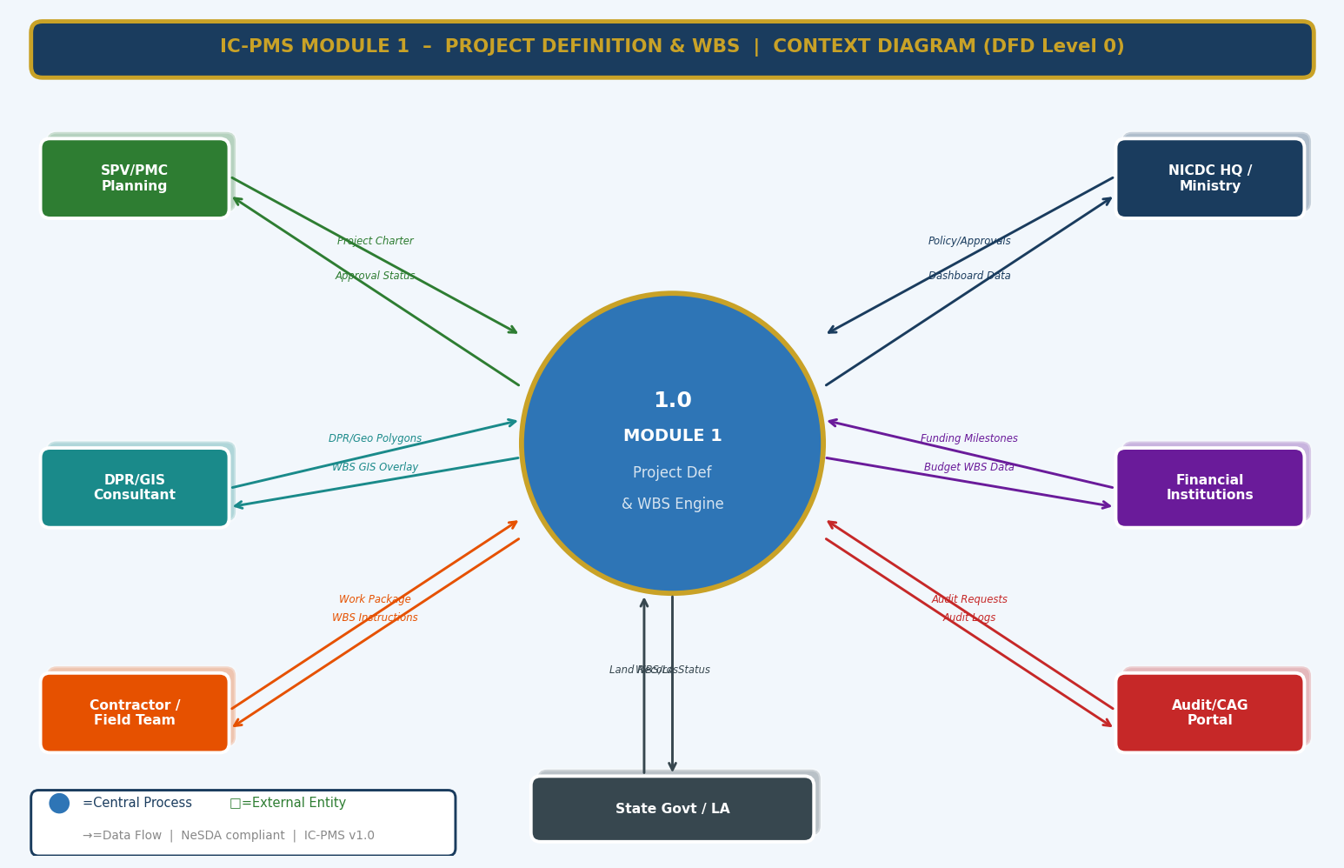
Figure 3.1 — DFD Level 0: Module 1 Context Diagram (All External Data Flows)

External Entity Data Flow Summary
External Entity | Inputs to Module 1 | Outputs from Module 1
SPV / PMC Planning Team | Project Charter, WBS Template Request, OBS Assignment | Approved WBS Structure, Confirmation Messages, Access Credentials
NICDC HQ / Ministry | Policy Directives, Approval Decisions, Funding Milestones | Executive Dashboard Data, Escalation Reports, Audit Exports
DPR / GIS Consultant | DPR Estimates, Geo-Polygons (.shp / GeoJSON), Cadastral Data | WBS-linked GIS Overlay, Geotag Confirmation, Spatial Summary
Financial Institutions | Funding Milestone Conditions, Loan Covenant Data | Budget-linked WBS Milestone Reports, Completion Certificates
Contractor / Field Team | Work Package Acceptance, Field Queries, GPS Waypoints | Assigned WBS Packages, Site Instructions, Boundary Maps
Audit / CAG Portal | Audit Requests, Compliance Queries | Full Audit Logs, Version History, Change Diff Reports
State Govt / LA Dept | Land Parcel Status Records, LA Gazette Notifications | WBS Land Acquisition Status, Pending LA by Package

3.2 DFD Level 1 — Main Processes & Data Stores
The Level 1 DFD decomposes Module 1 into six core processes and seven data stores, showing how data flows internally between them and to/from external entities. This diagram establishes the complete internal architecture of the module.
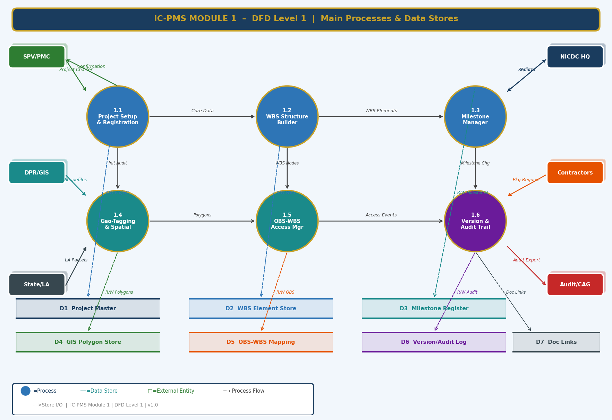
Figure 3.2 — DFD Level 1: Six Core Processes and Seven Data Stores

Process Descriptions — Level 1
Process | Name | Primary Function | Key Data Stores
1.1 | Project Setup & Registration | Creates and validates the Project Master record; triggers DMS folder and cost template | D1 Project Master
1.2 | WBS Structure Builder | Builds, validates, codes, and publishes the WBS hierarchy tree | D1, D2 WBS Element Store, D8, D9, D10
1.3 | Milestone & Phase Manager | Creates milestones, tracks progress, triggers escalations and PFMS gates | D3 Milestone Register, D6 Audit Log
1.4 | Geo-Tagging & Spatial Linker | Imports polygons, validates boundaries, links to WBS elements | D4 GIS Polygon Store
1.5 | OBS-WBS Link & Access Manager | Maps organisations to WBS nodes, enforces data access rules | D5 OBS-WBS Mapping, D1, D2
1.6 | Version Control & Audit Trail | Records all changes, manages versioning, generates audit exports | D6 Version/Audit Log, D7 Document Links

Data Store Descriptions
Data Store | Contents | Primary Processes
D1 Project Master | Project identity, metadata, DPR reference, status, SPV linkage | 1.1, 1.2, 1.5
D2 WBS Element Store | Full WBS tree with all element attributes, version, and status | 1.2, 1.5, 1.6
D3 Milestone Register | Milestone definitions, baseline/forecast dates, evidence, status | 1.3
D4 GIS Polygon Store | Geo-polygon geometries (PostGIS), area attributes, version | 1.4
D5 OBS-WBS Mapping | Organisation-to-WBS access assignments with role and dates | 1.5
D6 Version / Audit Log | Immutable change log for all WBS and project data modifications | 1.6 (writer), All (reader)
D7 Document Links | References to DMS documents attached to WBS elements | 1.6

3.3 DFD Level 2 — Process 1.2: WBS Structure Builder (Exploded)
The Level 2 diagram drills into Process 1.2 — the WBS Structure Builder — exposing its eight internal sub-processes, decision logic (hierarchy validation), and the full set of data store interactions. This is the most complex process in Module 1 and is the one most analogous to Primavera Unifier's WBS setup screens.
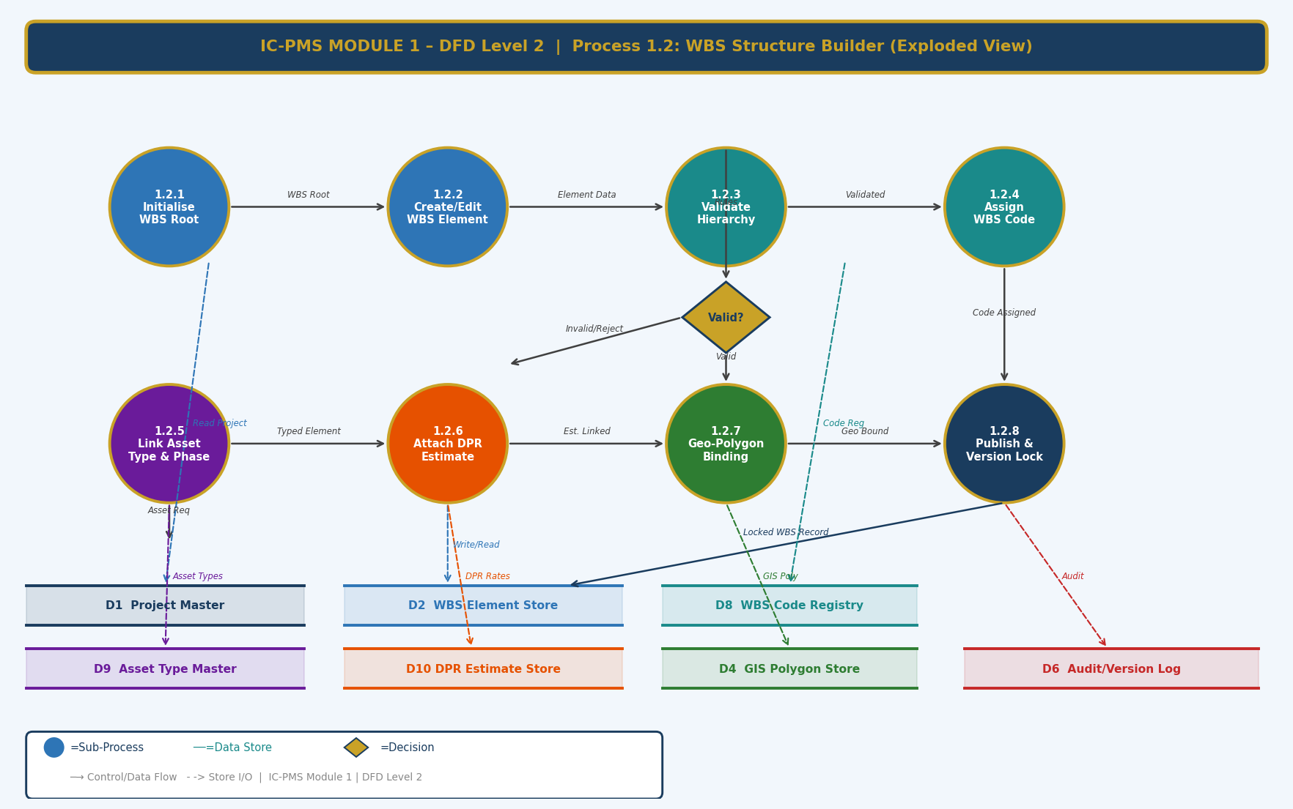
Figure 3.3 — DFD Level 2: Process 1.2 WBS Structure Builder — 8 Sub-Processes Exploded

Sub-Process Narrative — Process 1.2
Sub-Process | Name | Narrative Description
1.2.1 | Initialise WBS Root | Creates the Corridor-level WBS root node (Level 1) from the approved Project Master record. Reads D1 for project code and name; writes the root WBS element to D2. This is a one-time operation per project.
1.2.2 | Create / Edit WBS Element | The primary user-facing operation. User selects a parent node and adds a child element, filling the element form (name, type, phase, responsible agency). Writes candidate element to D2 with status = Draft.
1.2.3 | Validate WBS Hierarchy | Runs the validation engine: checks parent-child level rules, code uniqueness (query D8), mandatory field completeness, and geo-polygon presence for L3+. Routes to decision diamond: Valid → 1.2.4, Invalid → 1.2.2 with error report.
1.2.4 | Assign WBS Code (NIC) | Generates the NIC-format hierarchical code by reading the parent code from D2 and appending the next sequential suffix. Registers the code in D8 to enforce global uniqueness.
1.2.5 | Link Asset Type & Phase | Associates the WBS element with an Asset Type (read from D9) and a Project Phase. The Asset Type selection determines which Cost Template will be pre-loaded in Module 4.
1.2.6 | Attach DPR Estimate | Reads the matching cost estimate record from D10 (uploaded DPR data) and links it to the WBS element as the Baseline Cost. Creates the initial budget node in Module 4's cost ledger.
1.2.7 | Geo-Polygon Binding | Reads the polygon record from D4 (previously uploaded by GIS team via Process 1.4) and links it to the WBS element. Validates that the polygon CRS is WGS84 and area is within 5% of DPR boundary.
1.2.8 | Publish & Version Lock | On approval, creates a locked snapshot of all validated elements, sets status = Active, assigns version v1.0, writes the locked record to D2, and posts an audit entry to D6. Triggers Module 4 budget seeding and Module 2 schedule activity creation.

4. Master Data Model

4.1 Entity Relationship Overview
The Module 1 master data model consists of twelve core entities. The WBS Element is the central entity — everything else either provides reference data for it or is produced by it. The diagram below shows all entities, their key fields, and their relationships.
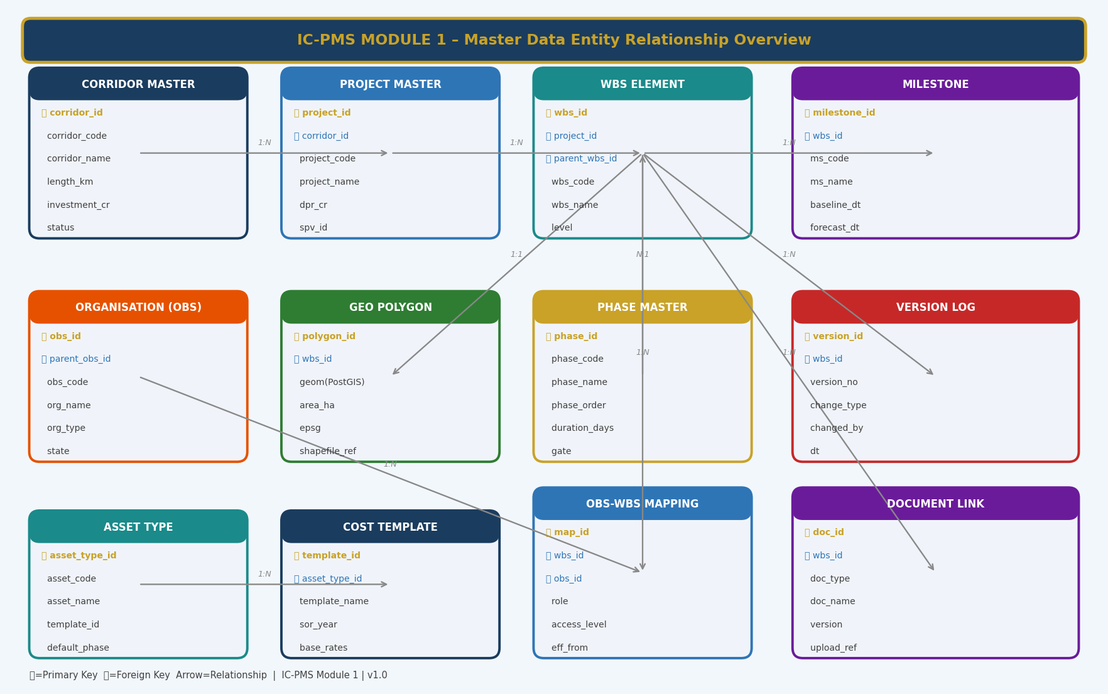
Figure 4.1 — Master Data Entity Relationship Overview (Module 1)

4.2 Entity Definitions

4.2.1 Corridor Master
The topmost reference entity. All six national industrial corridors are pre-loaded during system setup. Corridors cannot be created by SPV users — only by NICDC System Administrators.
corridor_id | UUID — Primary Key; system-generated
corridor_code | 6-char code: DMIC, CBIC, VCIC, AKIC, BMEC, HNIC
corridor_name | Full official name of the corridor
total_length_km | Corridor alignment length in kilometres
investment_cr | Approved investment in INR Crore
states_covered | Comma-separated list of state codes
status | Enum: Active / Under Planning / Suspended

4.2.2 Project Master
Each separately investable project within a corridor node. Corresponds to a Primavera Unifier 'Project' record.
project_id | UUID — Primary Key
corridor_id | FK → Corridor Master
zone_id / node_id | FK → Zone Master / Node Master (geographic hierarchy)
project_code | NIC-format code — globally unique
project_name | Official project name
dpr_value_cr | DPR-approved project cost in INR Crore
spv_id | FK → Organisation Master; the SPV responsible for delivery
pmc_id | FK → Organisation Master; the PMC engaged
phase | Current lifecycle phase
fy_sanction | Financial year of budget sanction
geo_boundary_id | FK → GIS Polygon Store; project extent boundary
project_status | Draft / Submitted / Approved / Active / Closed

4.2.3 WBS Element
The central entity of Module 1. Every project cost, schedule activity, satellite polygon, document, and risk is ultimately linked to a WBS Element record.
wbs_id | UUID — Primary Key
project_id | FK → Project Master
parent_wbs_id | FK → WBS Element (self-referencing for tree structure; NULL for root)
wbs_code | NIC hierarchical code — globally unique across all projects
wbs_name | Descriptive name
wbs_level | Integer 1–8
wbs_type | Enum: Summary / Work Package / Milestone
asset_type_id | FK → Asset Type Master
phase_id | FK → Phase Master
baseline_start / baseline_end | DATE — from DPR schedule
forecast_start / forecast_end | DATE — current forecast; updated by scheduler
baseline_cost_cr | DECIMAL — from DPR estimate
committed_cost_cr | DECIMAL — from Module 4 work orders
actual_cost_cr | DECIMAL — from Module 4 invoices
physical_progress_pct | DECIMAL — updated by Module 3 satellite or field input
geo_polygon_id | FK → GIS Polygon Store
responsible_obs_id | FK → Organisation Master
wbs_status | Draft / Submitted / Approved / Active / Superseded / Closed
version_no | e.g. v1.0, v1.2, v2.0

4.2.4 Milestone
milestone_id | UUID — Primary Key
wbs_id | FK → WBS Element (parent WBS the milestone belongs to)
milestone_code | e.g. M-DMIC-N03-007
milestone_name | e.g. Foundation Completion — Package 07
milestone_type | Physical / Regulatory / Financial / Contract / Handover
is_critical | Boolean — appears in all executive dashboards
baseline_date | DATE — original approved target date
forecast_date | DATE — current forecast; reason code required for any change
actual_date | DATE — set when evidence is approved
predecessor_milestone_id | FK → Milestone (self-referencing dependency)
lag_days | INTEGER — lag after predecessor
dependency_type | FS / SS / FF / SF
evidence_doc_id | FK → Document Links — proof of completion
pfms_trigger | Boolean — true if this milestone triggers a PFMS fund release
milestone_status | Enum: Planned / On Track / At Risk / Delayed / Completed / Superseded
traffic_light | Green / Amber / Red — computed field

4.2.5 Organisation (OBS) Master
obs_id | UUID — Primary Key
parent_obs_id | FK → Organisation (self-referencing for hierarchy)
obs_code | Unique code for the organisation
org_name | Full legal name of the organisation
org_type | Ministry / NICDC / SPV / PMC / EPC / Sub-Contractor / Lender / Auditor
state_code | State in which the organisation primarily operates
gstin | GST Registration Number — validated against GSTN API
nic_vendor_code | NIC procurement system vendor code (if applicable)

4.2.6 GIS Polygon Store
polygon_id | UUID — Primary Key
wbs_id | FK → WBS Element
geom | GEOMETRY(MultiPolygon, 4326) — stored in PostGIS
area_ha | DECIMAL — computed from geom
perimeter_km | DECIMAL — computed from geom
centroid_lat / centroid_lon | DECIMAL — computed centroid coordinates
crs_source | Original CRS before reprojection (e.g. EPSG:32643)
shapefile_ref | Path / URL to source shapefile in DMS
dpr_area_ha | DECIMAL — DPR-specified area for comparison
area_variance_pct | DECIMAL — (area_ha - dpr_area_ha) / dpr_area_ha × 100
polygon_version | INTEGER — increments on any boundary modification
upload_date / uploaded_by | Audit fields

4.2.7 Phase Master
phase_id | UUID — Primary Key
phase_code | e.g. P01, P02, P03, P04, P05, P06
phase_name | Feasibility / DPR / Land Acquisition / Construction / Testing & Commissioning / Handover
phase_order | INTEGER — defines sequence
duration_days | INTEGER — typical duration (indicative)
gate_criteria | Text — conditions that must be met for phase to be activated

4.2.8 Asset Type Master
asset_type_id | UUID — Primary Key
asset_code | e.g. ROAD, RAIL, POWR, WATR, ICT, BLDG, GREEN
asset_name | Road / Railway / Power / Water / ICT / Building / Green Infrastructure
default_cost_template_id | FK → Cost Template (default SOR-based template for this asset)
default_phase | Most common starting phase for this asset type
satellite_layer_type | Which satellite analytics layer applies: Construction / NDVI / Water

4.2.9 Version Log
version_id | UUID — Primary Key
entity_type | Enum: Project / WBSElement / Milestone / GeoPolygon / OBSMapping
entity_id | UUID — the specific record that was changed
version_no | e.g. v1.0, v1.2 — version of the entity after this change
change_type | Create / Edit / StatusChange / Delete / Rollback
changed_by | FK → User
change_timestamp | TIMESTAMP WITH TIME ZONE
change_ip | IP address of the user session
old_value_json | JSONB — snapshot of entity fields before change
new_value_json | JSONB — snapshot of entity fields after change
change_justification | TEXT — mandatory for structural WBS changes
hash_chain | VARCHAR(64) — SHA-256 hash of previous record + this record for tamper detection

5. UI/UX Screen Designs
The following five screens cover the primary user journeys in Module 1. The designs follow a dark-navy sidebar / light content area layout consistent across all IC-PMS modules. The colour system uses the national infrastructure palette: Navy (#1A3C5E), Gold (#C9A227), and Teal (#1A8A8A) as primary identifiers, with Green / Amber / Red for status signalling. All screens are responsive and optimised for desktop (1920×1080) and tablet (1366×768) form factors. A Progressive Web App (PWA) variant with offline capability is provided for field engineers on Android/iOS.

Screen 1 — Module 1 Dashboard
The Dashboard is the landing screen for any user entering Module 1. It provides an instant situational snapshot: programme-wide KPIs in summary cards, the WBS hierarchy navigator on the left, milestone progress tracker on the right, and a live activity log at the bottom.
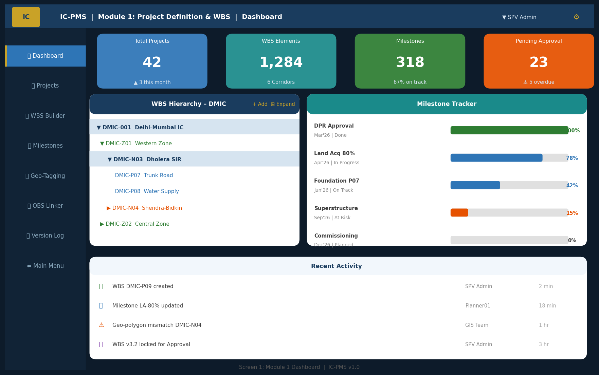
Figure 5.1 — Module 1 Dashboard (KPI Cards, WBS Navigator, Milestone Tracker, Activity Log)

Dashboard UI Components
Component | Description | Data Source
KPI Summary Cards (top row) | 4 cards: Total Projects, WBS Elements, Milestones, Pending Approvals. Colour-coded by status; clickable to filtered list view. | D1 Project Master, D2 WBS, D3 Milestones
WBS Navigator Panel (left) | Collapsible tree showing Corridor → Zone → Node → Package with colour-coded status dots. Supports search, filter by status, and 'Expand All'. | D2 WBS Element Store
Milestone Tracker (right) | Horizontal progress bars for top 5 milestones with date, status, and % complete. Red/Amber/Green colouring. | D3 Milestone Register
Activity Log (bottom) | Real-time feed of all WBS changes, approval events, geo-updates. Filterable by user/action type. | D6 Version/Audit Log
Navigation Sidebar | Module menu with icons; active module highlighted with gold left border. | Session state
Top Navigation Bar | IC-PMS brand, breadcrumb, corridor selector, user profile with role indicator. | Session / User Master

Screen 2 — WBS Structure Builder
The WBS Builder is the most-used screen in Module 1. It presents the complete project hierarchy in a left-panel navigator and the selected element's full detail panel on the right. Users spend most of their WBS configuration time here.
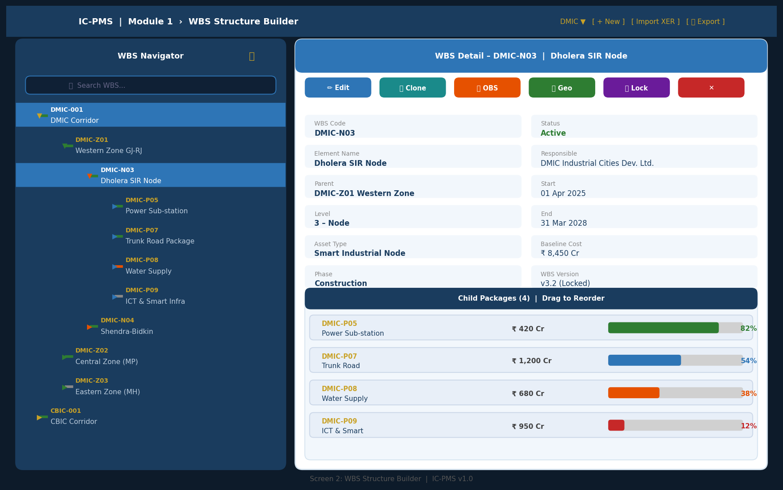
Figure 5.2 — WBS Structure Builder (Tree Navigator, Element Detail, Child Package Progress)

WBS Builder — Interaction Design
Interaction | Behaviour | Feedback
Click tree node | Loads full element detail in right panel | Right panel animates in; selected node highlighted in blue
Right-click tree node | Context menu: Add Child, Clone Sub-tree, Move, Lock, Deprecate | Context menu appears at cursor; destructive actions show confirmation
Drag node | Move WBS element to new parent; validation runs on drop | Ghost image follows cursor; drop targets highlighted; validation error shown inline
+ New Element button | Opens element creation form (Screen 3) | Form slides in as right panel overlay
Import XER / XML | File picker; system parses and previews import mapping | Preview table shows matched and unmatched elements; user confirms before import
Export | Generates P6 XER, MS Project XML, or Excel | Download prompt with format selector
Lock Element | Initiates approval workflow; element locked on approval | Status badge changes to 'Locked'; version number increments
Search box | Full-text search across WBS codes and names | Results highlighted in tree; non-matching nodes dimmed
Child package progress bars | Show cost and schedule progress per child; colour = RAG status | Clicking bar navigates to that child element

Screen 3 — WBS Element Create / Edit Form
The element form is a 6-step wizard that guides the user through all required data for a new WBS element. The wizard approach prevents overwhelming users with all fields at once and enforces logical sequence (basic info before financial data, financial data before geo-tagging).
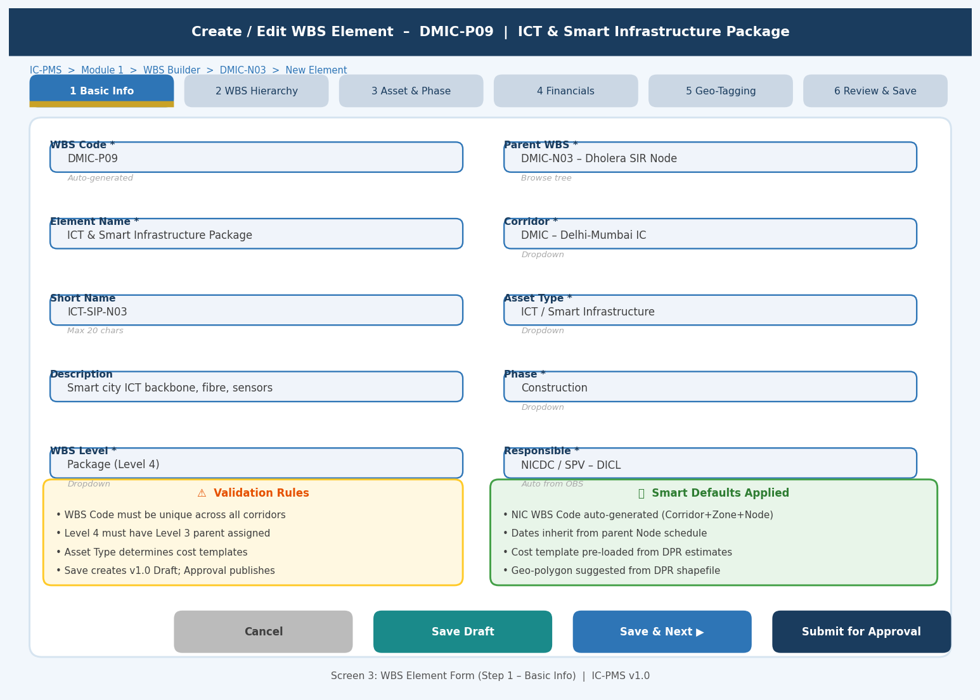
Figure 5.3 — WBS Element Form (Step 1: Basic Info — 6-Step Wizard with Validation & Smart Defaults)

Form Wizard — Step Summary
Step | Title | Key Fields | Completion Trigger
Step 1 | Basic Info | WBS Code (auto), Name, Short Name, Description, Level | All mandatory fields filled and validated
Step 2 | WBS Hierarchy | Parent WBS (tree picker), Corridor, Zone, Node (auto-filtered) | Valid parent selected; no circular reference
Step 3 | Asset & Phase | Asset Type (dropdown), Phase (dropdown), Responsible Agency (OBS picker) | Asset type and phase selected
Step 4 | Financials | Baseline Cost (₹ Cr), Cost Template (auto from asset type), DPR estimate link | Cost > 0 for Work Package type; zero allowed for Summary
Step 5 | Geo-Tagging | Upload shapefile / draw polygon / link existing polygon; CRS validation | Valid polygon linked; area variance < 5% of DPR (warning if exceeded)
Step 6 | Review & Save | Summary of all fields; diff view if editing existing element | User confirms; system runs full validation before saving

Form UX Principles
- Smart Defaults: NIC WBS Code auto-generated from parent code; dates inherit from parent element; cost template auto-selected from asset type
- Inline Validation: Each field validates on blur (not on submit), showing error immediately below the field
- Validation Summary Panel: Yellow warning box lists all pending issues; must be cleared before Save
- Smart Defaults Panel: Green info box shows all auto-populated values; user can override any
- Auto-save as Draft: System auto-saves form state every 60 seconds to prevent data loss
- Keyboard shortcuts: Tab to move between fields; Enter to confirm dropdowns; Ctrl+S to Save Draft

Screen 4 — Milestone & Phase Manager
The Milestone Manager provides a Gantt-style timeline view of all milestones within a selected WBS scope (project, node, or package). Users can add, edit, and link milestones, track progress against baseline, and attach evidence for completion.
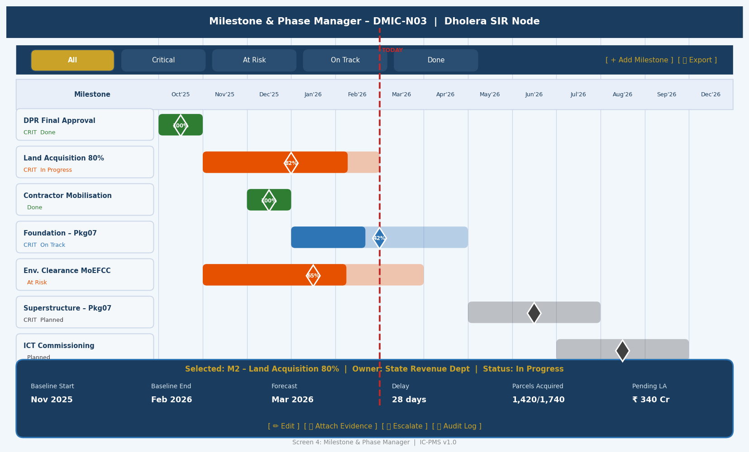
Figure 5.4 — Milestone & Phase Manager (Gantt Timeline, Status Filters, Selected Milestone Detail Panel)

Milestone Manager — Key UI Behaviours
UI Element | Behaviour
Filter bar | Single-click filters by status (All / Critical / At Risk / On Track / Done); multiple filters can be stacked
Timeline header | Monthly columns; scrollable horizontally for full project duration; 'Today' vertical red line always visible
Gantt bars | Width = duration from Baseline Start to Baseline End; fill % = progress; colour = traffic light status; hover shows tooltip with all dates
Diamond markers | Milestone marker at Baseline End date; gold fill = on track, orange = at risk, red = delayed, green = done
Selected milestone detail | Bottom panel shows full KPI set for selected milestone: baseline vs. forecast dates, delay days, related WBS, owner, LA counts
Action buttons | Edit opens the milestone edit form; Attach Evidence opens document upload; Escalate sends immediate alert to escalation contact; Audit Log shows full history
+ Add Milestone | Opens inline form in right panel without navigating away from timeline

Screen 5 — Geo-Tagging & Spatial Linker
The Geo-Tagging screen is an interactive GIS map viewer where WBS polygon boundaries are visualised, edited, and validated. It is the spatial workspace for GIS teams, PMC engineers, and NICDC spatial analysts.
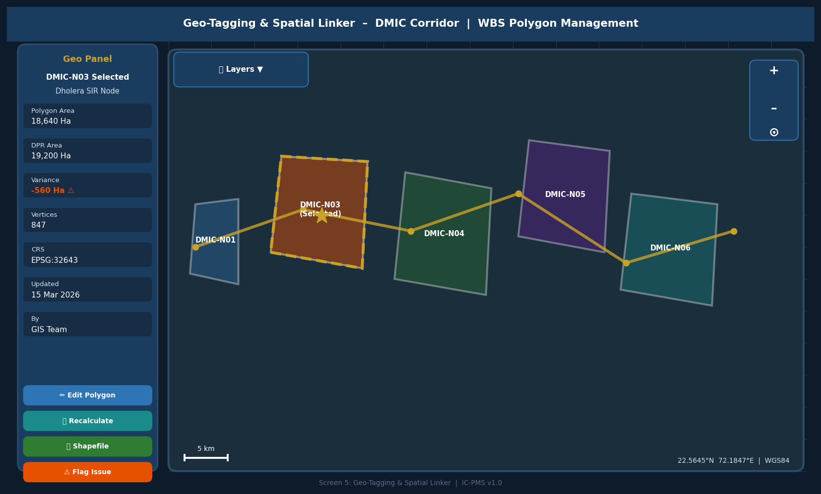
Figure 5.5 — Geo-Tagging Screen (Interactive Map, WBS Polygon Overlay, Spatial Attribute Panel)

Map UI Features
- Base layer options: OpenStreetMap, ISRO Bhuvan (LISS-IV), Cartosat-3 (sub-0.25m), ESRI World Imagery — toggled via layer control
- WBS polygon overlay: Each WBS polygon rendered as a semi-transparent coloured layer; colour = WBS status; gold dashed border = currently selected element
- Corridor alignment line: Gold polyline showing the corridor road/rail centreline for spatial reference
- Polygon selection: Click on polygon to select; left panel loads spatial attributes and action buttons
- Area variance alert: Orange badge on panel if polygon area deviates > 5% from DPR approved area
- Edit polygon: Opens vertex editor; each vertex draggable; 'Recalculate' recomputes area and updates D4
- Shapefile upload: Drag-and-drop shapefile set (.shp, .dbf, .prj, .shx) directly on map; auto-reprojected and previewed before save
- GPS waypoint import: Field engineer uploads CSV of waypoints from mobile app; system reconstructs polygon
- Map controls: Zoom in/out, north arrow, scale bar, coordinate display (WGS84 lat/long)
- Encroachment alert: Red overlay when two WBS polygons of different elements overlap; alert logged in D6

6. Business Rules & Validation Logic

6.1 WBS Structural Rules
Rule ID | Rule Description | Error Message / Action
WBS-001 | WBS Code must be globally unique across all projects and corridors | Error: 'WBS Code already exists in system. Please use a different suffix.'
WBS-002 | A WBS Element's level must be exactly Parent Level + 1 | Error: 'Element level must be one greater than parent level.'
WBS-003 | WBS elements of type Work Package cannot have children (leaf nodes only) | Error: 'Work Package elements cannot have child elements. Change type to Summary first.'
WBS-004 | WBS elements at Level 3 (Node) and below must have a GIS polygon linked before status can move to Active | Warning on save; blocking error on Submit for Approval
WBS-005 | Baseline End date must be >= Baseline Start date | Error: 'End date cannot be before start date.'
WBS-006 | Baseline Cost for a Summary element must equal the sum of its children's baseline costs | Warning: 'Parent cost (₹X Cr) differs from sum of children (₹Y Cr). Please reconcile.'
WBS-007 | A WBS element cannot be its own ancestor (circular reference check) | Error: 'Cannot set this element as parent — circular reference detected.'
WBS-008 | DPR document must be uploaded and linked before Project status can move from Draft to Submitted | Blocking error: 'DPR document is required before submission.'

6.2 Milestone Rules
Rule ID | Rule Description | Outcome
MS-001 | A milestone's Forecast Date cannot be set earlier than today without NICDC Director approval | Requires approval workflow if forecast moved earlier than current date
MS-002 | A PFMS-linked milestone cannot be marked Complete without evidence document upload | Blocking: 'PFMS-linked milestone requires evidence before completion.'
MS-003 | If a predecessor milestone is Delayed (Red), system auto-flags all successor milestones as At Risk | Cascade status update; notifications sent to successor owners
MS-004 | Milestone completion requires a physical progress % of >= the configured threshold (default 100% for Physical type) | Blocking until progress meets threshold
MS-005 | A Critical milestone delayed by > 30 days auto-escalates to NICDC Programme Director | System auto-sends escalation email/SMS; escalation logged in D6

6.3 Geo-Polygon Rules
Rule ID | Rule Description | Outcome
GEO-001 | Polygon CRS must be WGS84 (EPSG:4326) after import (auto-reprojection applied) | Warning if source CRS is unusual; error if reprojection fails
GEO-002 | Polygon area must be > 0 Ha and < 50,000 Ha (configurable per corridor) | Error: 'Polygon area is outside acceptable range.'
GEO-003 | A WBS polygon must not overlap > 10% with another WBS element's polygon (encroachment detection) | Warning: 'Overlap detected with [WBS Code]. Review boundaries before saving.'
GEO-004 | Polygon area variance from DPR boundary must be < 5% to proceed without override | Warning with mandatory justification text if variance exceeded
GEO-005 | A polygon version increment (boundary modification) requires SPV PM approval | Approval workflow triggered; old version archived; new version tagged as pending

7. Integration Touchpoints

7.1 Internal Module Integrations
Target Module | Data Exchanged | Trigger
Module 2 – Scheduling | WBS element codes, baseline dates, milestones, OBS assignments | On WBS Publish (status → Active); auto-creates activity stubs in scheduler
Module 3 – Satellite Integration | WBS geo-polygon bounds (WMTS spatial filter), WBS codes for progress overlay | On polygon registration; recurring for active polygons
Module 4 – Cost Management | WBS cost node hierarchy, baseline costs per element, cost template | On WBS Publish; budget tree seeded in cost module
Module 5 – Contract Management | WBS element codes as contract deliverable reference | On contract award; LOA linked to WBS package
Module 6 – Document Management | Auto-creates DMS folder hierarchy mirroring WBS tree | On WBS Publish; folder structure generated
Module 7 – Risk Management | WBS element codes as risk register anchor | On risk creation; risk linked to WBS scope
Module 9 – Reporting | All WBS attributes, milestone status, geo-polygon centroids | Real-time read for dashboard and report generation

7.2 External System Integrations
External System | Integration Type | Data Flow | Notes
PFMS (CGA) | REST API | Financial disbursement milestones trigger PFMS payment queue | OAuth 2.0; retry logic with 3-attempt limit
ISRO Bhuvan / NIC DigiLocker | WMTS + OAuth 2.0 | WBS polygon bounds used for satellite scene ordering | Scene ordered within 2 hours of polygon registration
DLRMS (State Land Records) | REST API | Land parcel status fetched per WBS LA polygon | State-specific API endpoints; 24-hour cache
MoEFCC PARIVESH | REST API | Environmental clearance status linked to relevant WBS milestones | Webhook on clearance status change
GSTN | REST API | Contractor GST compliance check on OBS master creation | Daily sync; non-compliant orgs flagged in OBS list
Primavera P6/Unifier | XER / REST | Bidirectional: WBS exported to P6 XER; schedule imported back | On-demand via 'Sync with P6' action in WBS Builder

8. Workflow States & Approval Chains

8.1 WBS Element Lifecycle
State | Entry Condition | Permitted Actions | Exit Condition
Draft | Element created by any Contributor role | Edit all fields; add children; preview | User submits for approval; validation passes
Submitted | All validations pass; submitted by SPV PM | View only; withdraw to Draft if error found | SPV Director reviews and approves or rejects
Approved | SPV Director approves | View only; edit requires new version draft | NICDC countersign (for nodes ≥ ₹500 Cr)
Active (Baseline v1.0) | Final approval received | View; initiate change request for any edit | Change approved → versioned edit; project closed → Closed
Versioned Edit | Change request approved; new version in draft | Edit within approved change scope | Re-approval at SPV/NICDC level depending on change magnitude
Superseded | Replaced by a newer version | View (read-only) for audit purposes | Terminal state; never deleted
Closed | Project phase complete or project terminated | View only | Terminal state

8.2 Approval Chain by Change Type
Change Type | Approver Level 1 | Approver Level 2 | Notes
New WBS Element (< ₹50 Cr) | SPV PM | SPV Director | Single level for small packages
New WBS Element (₹50–500 Cr) | SPV Director | NICDC Programme Director | Two-level approval required
New WBS Element (> ₹500 Cr) | SPV Director | NICDC MD + Ministry note | CCEA information note required
WBS Scope Change (structural) | SPV Director | NICDC Programme Director | Mandatory change justification ≥ 50 chars
Baseline Date Revision | SPV PM | SPV Director | RCA (Root Cause Analysis) document required
Baseline Cost Revision (VO < 10%) | SPV PM | SPV Director (via VO workflow) | Links to Module 5 VO module
Baseline Cost Revision (VO > 10%) | SPV Director | NICDC + Ministry concurrence | GFR Rule 209 applies
GIS Polygon Modification | GIS Team | SPV PM | Area variance > 5% requires SPV Director also

9. Performance & Non-Functional Requirements
Requirement | Specification | Measurement
WBS Tree Load Time | < 3 seconds for a tree of up to 5,000 elements | Lighthouse performance audit; P95 under load
Search Response | < 1 second for full-text WBS code/name search | Query profiling with EXPLAIN ANALYZE on PostgreSQL
Polygon Import | < 30 seconds for a shapefile with up to 10,000 vertices | End-to-end import timing including GDAL reprojection
Audit Log Query | < 2 seconds to retrieve 12-month audit trail for any WBS element | Elasticsearch query response time
Concurrent Users | 200 simultaneous users on Module 1 without degradation | k6 load test at 200 VUs for 30 minutes
WBS Export (XER) | < 60 seconds for full corridor WBS (up to 2,000 elements) | Export job completion time
Geo-Polygon Overlay Render | < 2 seconds to render all polygons for a full corridor on map | MapLibre GL tile render time
Approval Notification Delivery | < 30 seconds from approval trigger to email/SMS delivery | End-to-end notification latency
Data Backup | Daily incremental; weekly full; tested restore quarterly | Backup completion log and restore drill records
Audit Log Retention | 30 years in line with GFR 2017 records schedule | Automated archival to cold storage after 5 years active

10. Glossary — Module 1 Terms
Term | Definition
WBS | Work Breakdown Structure — hierarchical decomposition of project scope into manageable elements
OBS | Organisation Breakdown Structure — hierarchy of organisations involved in delivering the project
DPR | Detailed Project Report — the pre-investment technical and financial feasibility document
SPV | Special Purpose Vehicle — the project company incorporated to execute a specific industrial node
NIC Code | National Industrial Corridor coding convention for unique WBS element identification
PFMS | Public Financial Management System — GoI's central treasury and payment system
ISRO Bhuvan | National geospatial portal of ISRO providing access to Indian satellite imagery
PostGIS | PostgreSQL extension for storing and querying geospatial data
CRS | Coordinate Reference System — the framework defining how coordinates are mapped to Earth
WGS84 | World Geodetic System 1984 — the standard global coordinate system (EPSG:4326)
GeoJSON | Open standard for encoding geographic data structures in JSON format
WMTS | Web Map Tile Service — OGC standard for serving pre-rendered map tiles
XER | Oracle Primavera P6 native exchange format for project schedule and WBS data
GFR 2017 | General Financial Rules 2017 — Government of India's financial management regulations
CAG | Comptroller and Auditor General of India — the supreme audit institution
EVM | Earned Value Management — project performance measurement methodology
FS/SS/FF/SF | Finish-to-Start / Start-to-Start / Finish-to-Finish / Start-to-Finish — milestone dependency types
NDVI | Normalised Difference Vegetation Index — satellite-derived vegetation health indicator
PMC | Project Management Consultant — third-party firm engaged for design, supervision, and DPR
LOA | Letter of Award — formal document issuing a contract to a selected bidder

